Simple First Aid Anyone Can Do to Help a Downed Rider

 What every motorcyclist ought to know before tending to an injured rider.
Published on 05.22.2015
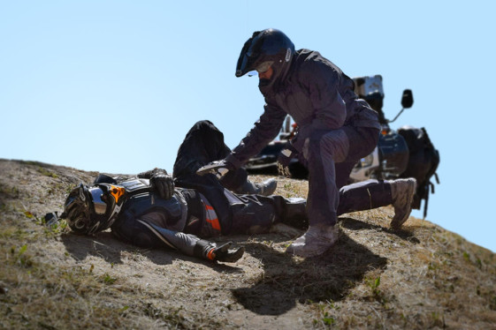
When a serious injury occurs to a fellow rider, do you know what to do next?
Falling down is quite common in Adventure Riding and we all can expect to go down at some point. We realize there’s a risk of cuts, scrapes, bruises and the occasional serious injury, so we go to great lengths protecting our bikes and bodies from the inevitable fall with high-tech gear and accessories.
While adventure riding grants us the remoteness we seek, it also takes us further away from aid when someone does get hurt. As a sweep-rider and paramedic for an Adventure Bike tour company, I’ve tended to more than a few injured riders. Usually, the injuries are minor but every once in a while, an injury is significant enough to require more definitive care.
So what do you do if you come across a downed rider? Hopefully, you’ve already taken a basic First Aid course and have an idea of what to do next. But if you haven’t taken a First Aid course “Yet” there are a few simple things you can still do to ensure you are able to provide help rather then hurt an injured rider.
Adventure Riders may encounter all sorts of injuries ranging from bee stings to broken bones or head and neck injuries.
Make Sure the Scene is Safe
- Don’t get sucked into an unsafe situation. People turn their backs to oncoming traffic all the time when distracted by an accident, putting themselves in a position to become a huge target for the next unsuspecting rider to fixate on.
- Delegate someone early to a safe part in the road or trail to warn oncoming traffic if needed.
- No running or yelling. Be calm but assertive and be alert to everything around you so you can provide an accurate report to Emergency Medical Services (EMS).
Call for Help
- If there is no cell service, or other means of alerting emergency services such as a GPS messenging device, send someone responsible to go get help and return only after they have made contact with emergency services.
- Agree on the accident scene location that will be reported to first responders.
- Make sure the person reporting to authorities knows how many people are injured; this is important in assigning the appropriate number of resources to the scene as early as possible.
Calm and Reassure the Patient
- In my experience, people know when you’re telling the truth. If you have a deer in the headlights look while you yell, “you’re going to be ok man!” don’t be surprised if the injured rider starts to tune you out.
- It is better to be honest with them and say things like, “your leg appears to be broken”, “you took a hard fall but we are going to help you until help arrives”, and “don’t move just in case you are hurt somewhere else”, etc.
- If the injured person is standing, ask them to sit or lay down in a safe place. If they are already lying down, place your hand on their chest to dissuade them from getting up and calmly ask them a few questions:
1.) What’s your name?
Find out if they are at least conscious enough to say their name and reassure them by telling them yours.
2.) How are you doing?
Pay attention to what their initial complaint is, as well as any difficulty of speech when describing it to you. Tell them that they were just in a motorcycle accident and help is coming (if they seem initially disoriented).
3.) What hurts?
Keep in mind that sometimes the injured person may be worked up after the accident and they may not feel or be able to report the full extent of their injuries. A broken leg or rib may distract the patient from other more serious, but less immediately painful injuries such as organ rupture or cervical neck injuries. This is why it is important that they remain still until more serious injuries can be assessed and/or ruled-out by the Emergency Medical Services responding to the accident.
4.) What do you remember?
Pay attention to the response because repetitive questions or the inability to recall the event suggests significant forces to the head strong enough to injure the brain; damage to the helmet is a good indicator of this. Note: any force to the head that results in loss of consciousness for any amount of time indicates either a concussion, or worse, a cerebral contusion, which may manifest into a more life threatening condition several hours after the trauma as the swelling/bleeding in the brain progresses. We’ve all heard about the person who hits their head and then goes to sleep, never to wake up: that’s a brain bleed.
- Always take into consideration a possible neck injury, and don’t make an existing one worse. Take any complaint of neck pain very seriously. It is widely known that moving a person with neck trauma can cause further injury and should only be done by EMS professionals.
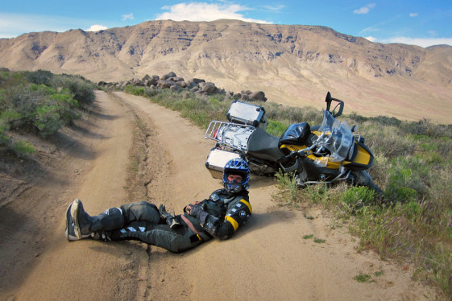
Make sure the injured rider stays relaxed, so they don’t panic and cause further damage to themselves.
To Move or Not to Move?
- It comes down to your safety to answer that. You cannot render any care in an unsafe environment. So, if you feel safe there, then you probably are; if you don’t feel safe there, move the person (and yourself).
- Other considerations for moving someone would be very hot pavement, moving an injured limb into a more neutral/comfortable position, or in the case of prolonged sun exposure, to seek shade.
- Depending on the type of the injury and severity, the injured person may be able to assist in moving him or herself to a safer place. For example, a person with a broken arm or ribs may still be able to get up and move into safety if they are alert, oriented, and have no other obvious injury. Use common sense.
Helmet On or Helmet Off?
- As a rule of thumb, if the injured rider is having significantly labored breathing, or perhaps not breathing at all, this is where you would remove the helmet carefully without jarring the persons head or neck. This is a two-person job. Some helmets have quick release pads that make this process smoother.
- It must be stressed that the only time you would remove the helmet would be to administer life-saving treatment such as cardiopulmonary resuscitation or to clear an obstructed airway (such as blood or vomit).
- If the person is breathing without difficulty, leave the helmet on as it can be used in spinal immobilization by the EMS responders. Again, consider any complaint of neck pain as the paramount reason to leave the helmet ON unless further life-saving measures are needed such as CPR.
Get Some Training
Many riders carry a medical kit in their luggage “just in case.” Unfortunately, most don’t really know what to do with it. First Aid Training courses are easy to find and affordable. You will learn to recognize and care for a variety of first aid emergencies such as burns, cuts, scrapes, sudden illnesses, head, neck, back injuries, heat and cold emergencies and how to respond to breathing and cardiac emergencies. And these skills can be used anywhere throughout your life, not just while riding.
Also consider a more definitive Wilderness Trauma First Responder course that will not only teach medical treatment but also provide you with the tools to make critical medical and evacuation decisions in remote locations. Check with your local Red Cross chapter or search online for reputable training programs available in your area.
About the Author: Sharif Massoud has been a 911 paramedic since 2001 and has worked in Ventura and Los Angeles counties. His duties have allowed him to work in an ambulance, SAR Helicopter, and motorcycle detail. He is currently a sweep-rider and head paramedic for RawHyde Adventures, and also the operator of RawHyde’s ADV Rentals in Castaic, CA.

