Tyre Markings

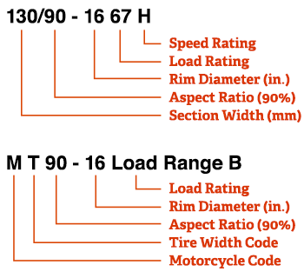
Tyre Index

AD INDEX | KG PER TYRE | LOAD INDEX | KG PER TYRE | LOAD INDEX | KG PER TYRE | LOAD INDEX | KG PER TYRE
60 | 250 | 90 | 600 | 120 | 1400 | 150 | 3350
61 | 257 | 91 | 615 | 121 | 1450 | 151 | 3450
62 | 265 | 92 | 630 | 122 | 1500 | 152 | 3550
63 | 272 | 93 | 650 | 123 | 1550 | 153 | 3650
64 | 280 | 94 | 670 | 124 | 1600 | 154 | 3750
65 | 290 | 95 | 690 | 125 | 1650 | 155 | 3875
66 | 300 | 96 | 710 | 126 | 1700 | 156 | 4000
67 | 307 | 97 | 730 | 127 | 1750 | 157 | 4125
68 | 315 | 98 | 750 | 128 | 1800 | 158 | 4250
69 | 325 | 99 | 775 | 129 | 1850 | 159 | 4375
70 | 335 | 100 | 800 | 130 | 1900 | 160 | 4500
71 | 345 | 101 | 825 | 131 | 1950 | 161 | 4625
72 | 355 | 102 | 850 | 132 | 2000 | 162 | 4750
73 | 365 | 103 | 875 | 133 | 2060 | 163 | 4875
74 | 375 | 104 | 900 | 134 | 2120 | 164 | 5000
75 | 387 | 105 | 925 | 135 | 2180 | 165 | 5150
76 | 400 | 106 | 950 | 136 | 2240 | 166 | 5300
77 | 412 | 107 | 975 | 137 | 2300 | 167 | 5450
78 | 425 | 108 | 1000 | 138 | 2360 | 168 | 5600
79 | 437 | 109 | 1030 | 139 | 2430 | 169 | 5800
80 | 450 | 110 | 1060 | 140 | 2500 | 170 | 6000
81 | 462 | 111 | 1090 | 141 | 2575 | 171 | 6150
82 | 475 | 112 | 1120 | 142 | 2650 | 172 | 6300
83 | 487 | 113 | 1150 | 143 | 2725 | 173 | 6500
84 | 500 | 114 | 1180 | 144 | 2800 | 174 | 6700
85 | 515 | 115 | 1215 | 145 | 2900 | 175 | 6900
86 | 530 | 116 | 1250 | 146 | 3000 | 176 | 7100
87 | 545 | 117 | 1285 | 147 | 3075 | 177 | 7300
88 | 560 | 118 | 1320 | 148 | 3150 | 178 | 7500
89 | 580 | 119 | 1360 | 149 | 3250 | 179 | 7750

Tyre Speed Index
The KM/H is measured at sustained maximum speed.
SPEED SYMBOL | SPEED (KM/H)
E | 70
F | 80
G | 90
J | 100
K | 110
L | 120
M | 130
N | 140
P | 150
Q | 160
R | 170
S | 180
T | 190
U | 200
H | 210
V | 240
W | 270
Y | 300
Z & ZR | 240+

